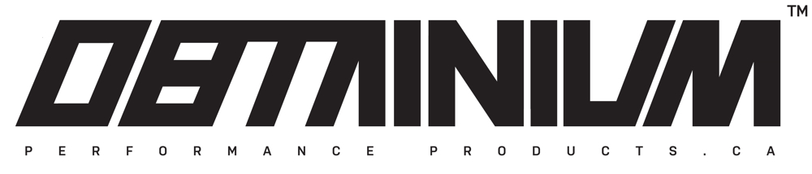
WARRANTY REQUEST FORM
Model:
Year:
Size:
Description of Problem:

*RA#:
Dealer Name:
Address:

Contact:
Phone:
Product Owner:
Phone:
------------------------------------------------------------------------------------------------------------
CONTACT US
Email: info@obtainiumperformanceproducts.ca

MUST INCLUDE COPY OF RECEIPT
*MANDATORY. Please email or call us for RA# (Return Authorization Number)

